**Instructions on**

**Navigating KV Food Delivery Service via a Local Server**

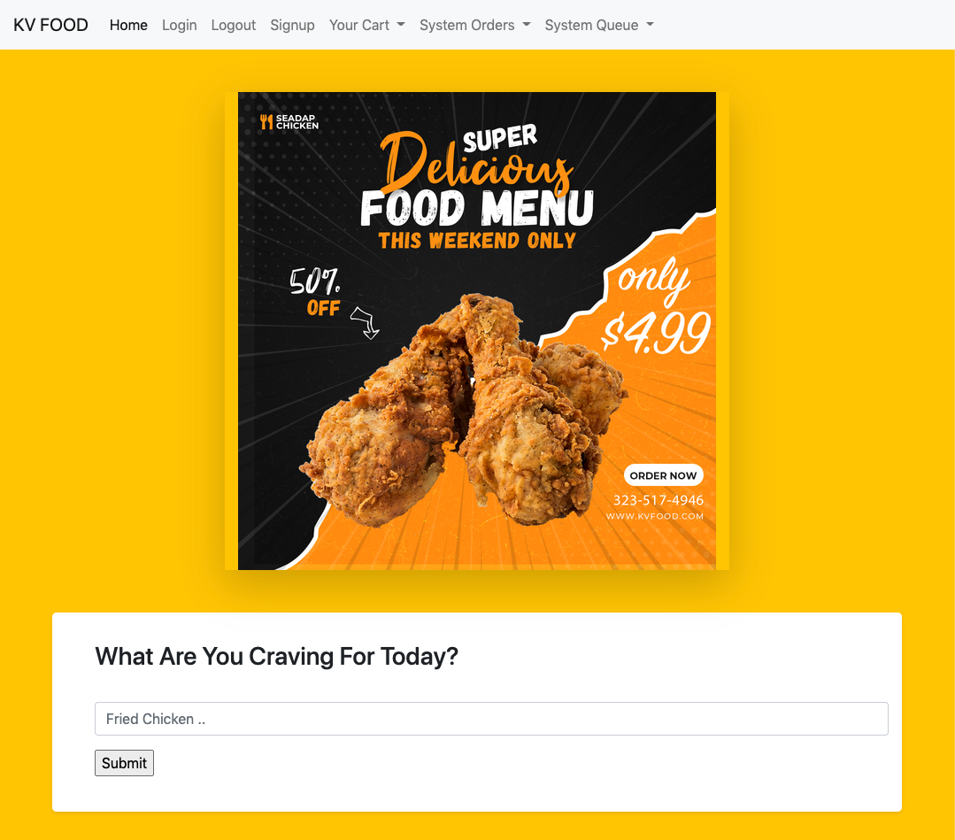

1. **Set up MySQL & start the Server**

MySQL dump file has been included in the root directory. Please import into your mySQL and change login credentials in main.go (line 140).

CD into the directory where you unzipped the file and the following commands in your terminal:

*go run .*

1. **Launch a Client Website**

You can use a client such as chrome to access the server at your local address:

*localhost:8080*

There is no need for a http:// or https:// right in front of the link.

1. **You can either start searching or signing up!**

On the home page, you can either start searching, or use the login button found on the nav bar.

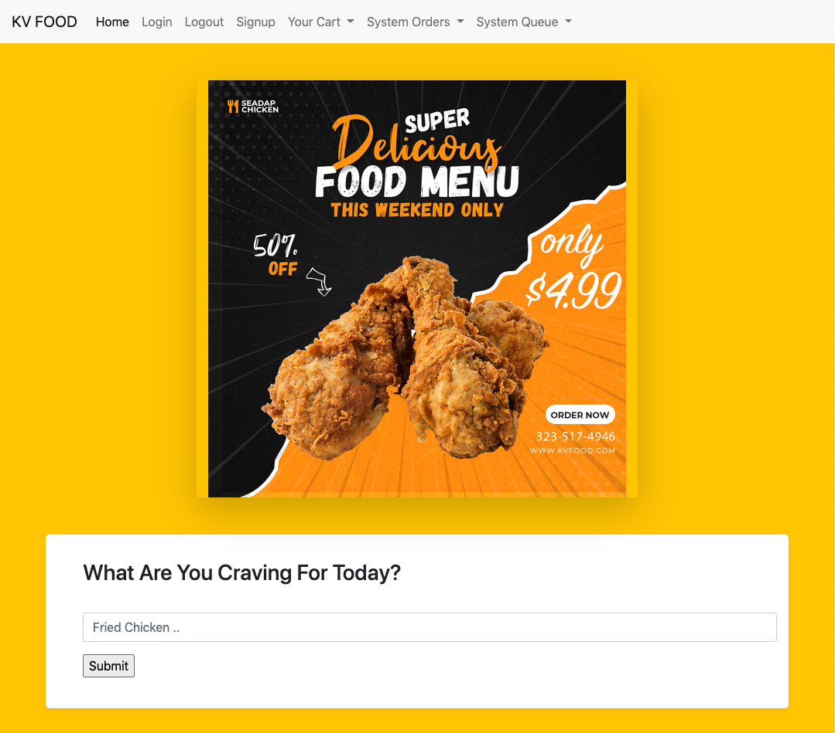

1. **If you search, you'll get redirected and get greeted with options**

Choose sign up, if this is your first time with us. If you don't make any selections, you'll get redirected to the sign up page.

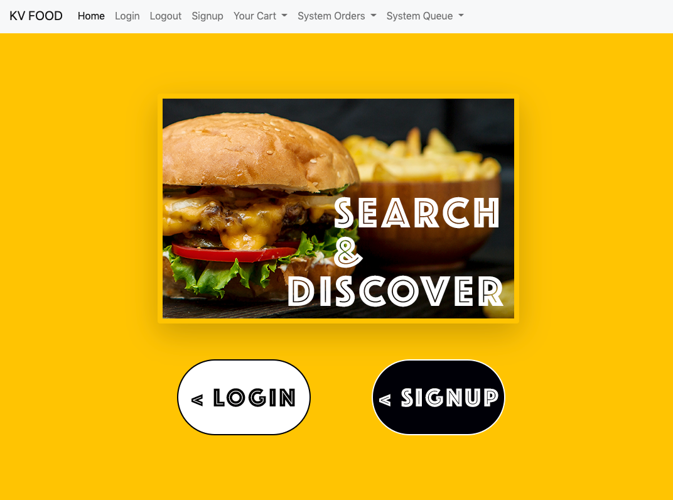

1. **Sign up with your preferred information**

Please sign up with information that is *accurate*. There are no regex checks except for the email field. Please enter a valid email format such as [myemail@email.com](mailto:myemail@email.com)

Please submit relevant information on all other fields. *Empty Fields will result in error messages.*

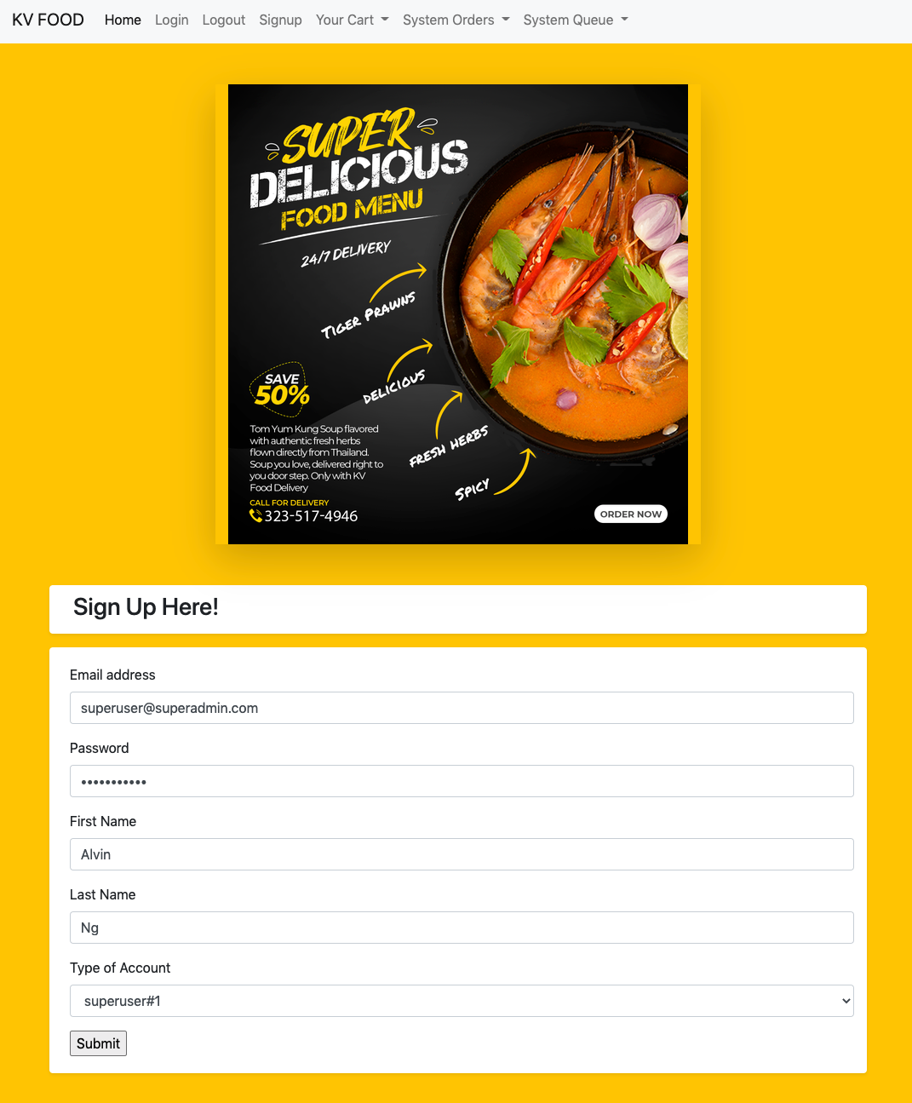

1. **Start Searching. Fried Chicken is good!**

While the database does not contain all the food items in the world, you can get to test the program out. Search for *fried chicken .* Not **Fried Chicken.** The program only accepts small case letters now.

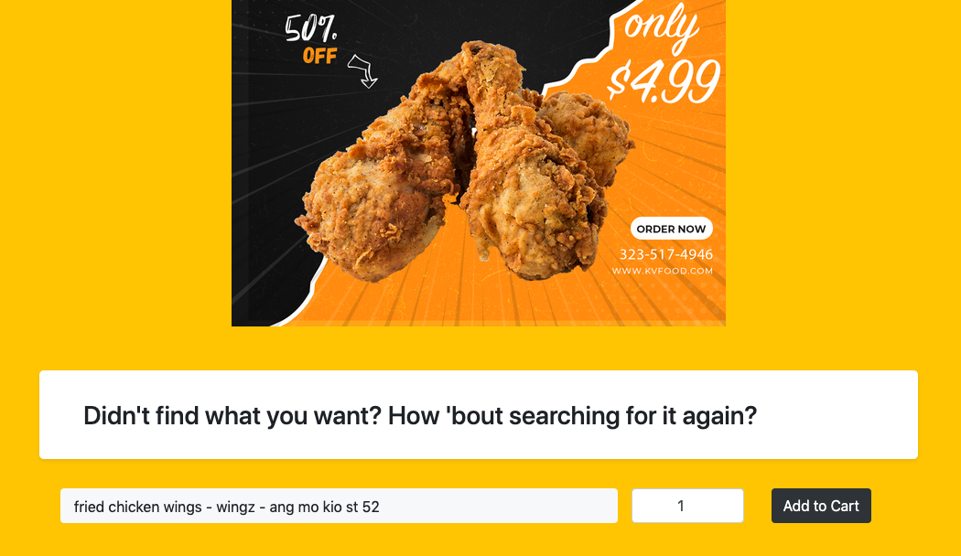

1. **Change quantity and Add to Cart**

Want just one quantity? If not, you can change it by entering different values; or hover your mouse over it and use the arrows to change the values. Once you're ready, hit the "Add to Cart" button.

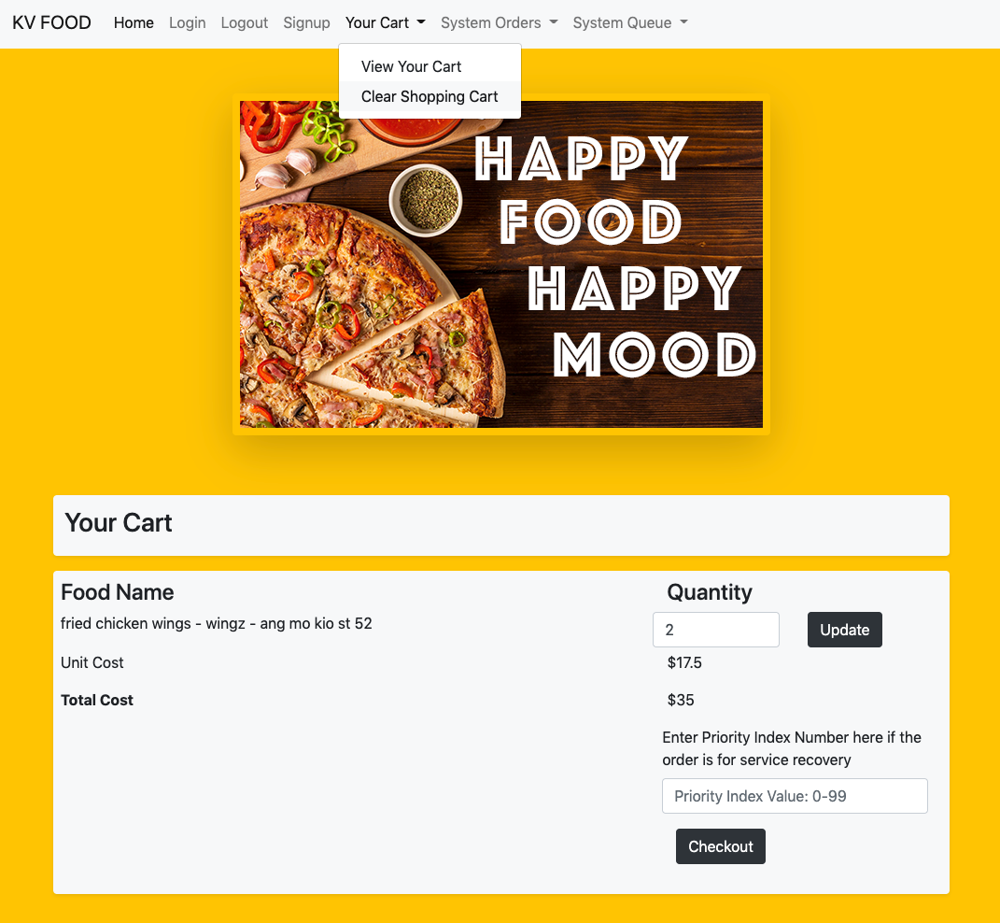

1. **Like what you selected? No?**

Don't like what you selected? What about clearing your cart? Or emptying your shopping cart? It's just one click away. Find it at the top nav bar as shown in the picture. Or perhaps you've changed your mind regarding the quantity.

You can try increasing, decreasing or even setting the quantity to 0. Just remember to hit the enter button or press the Update button. Warning: (you'll be greeted with a sad face if your cart is empty)

1. **Superuser#1 is really super in the app**

With admin privileges, superuser#1, your account type has access to menus that other account types do not have. You can demonstrate your authority by keying in a priority value. Be sure you have at least 1 item in your cart.   
  
A priority value is a value that is used for service recovery orders. For example, there's a super angry customer because the previous rider somehow messed up. This angry customer cannot wait for his food to come in the next 1 hour while the merchant serves other orders first. A quick service recovery means the new order you are going to put through has to **jump the queue**.

Good thing it's easy to set right here.

Go ahead and set the priority value to 99 and press the "Checkout" button

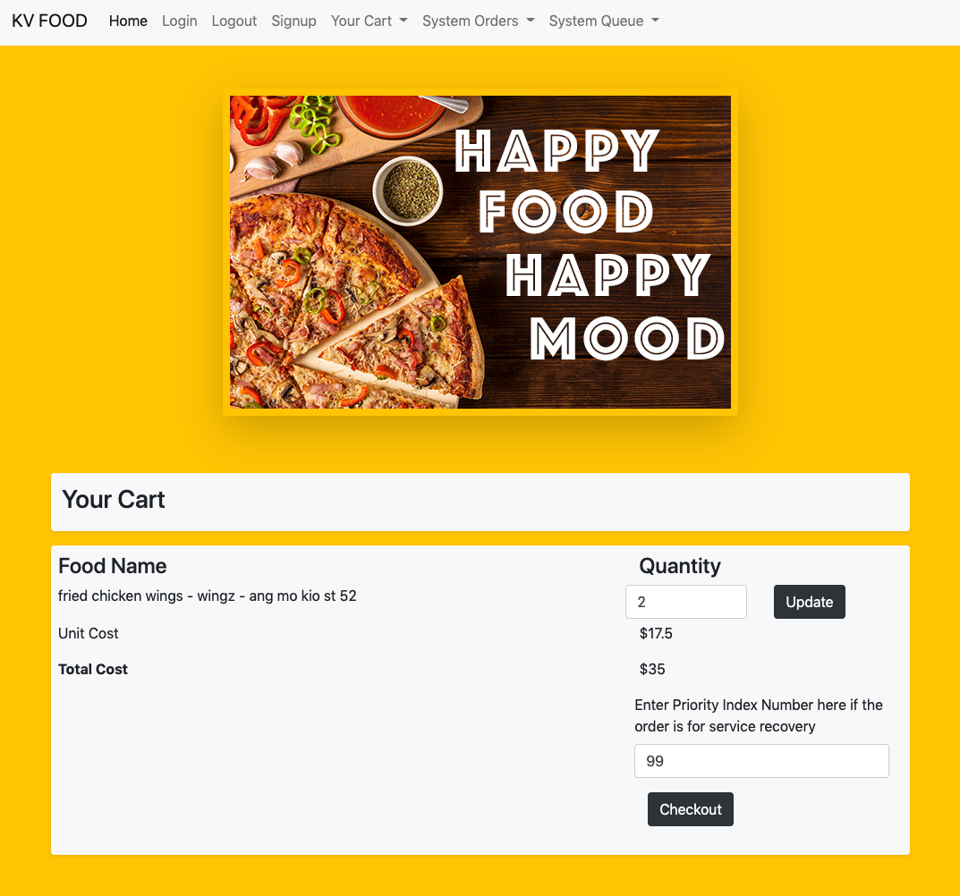

1. **Checkout is successful!**

If your checkout is successful, you'll be greeted with your checked-out goods. Your order number, your food name, the quantity and the total amount you paid.

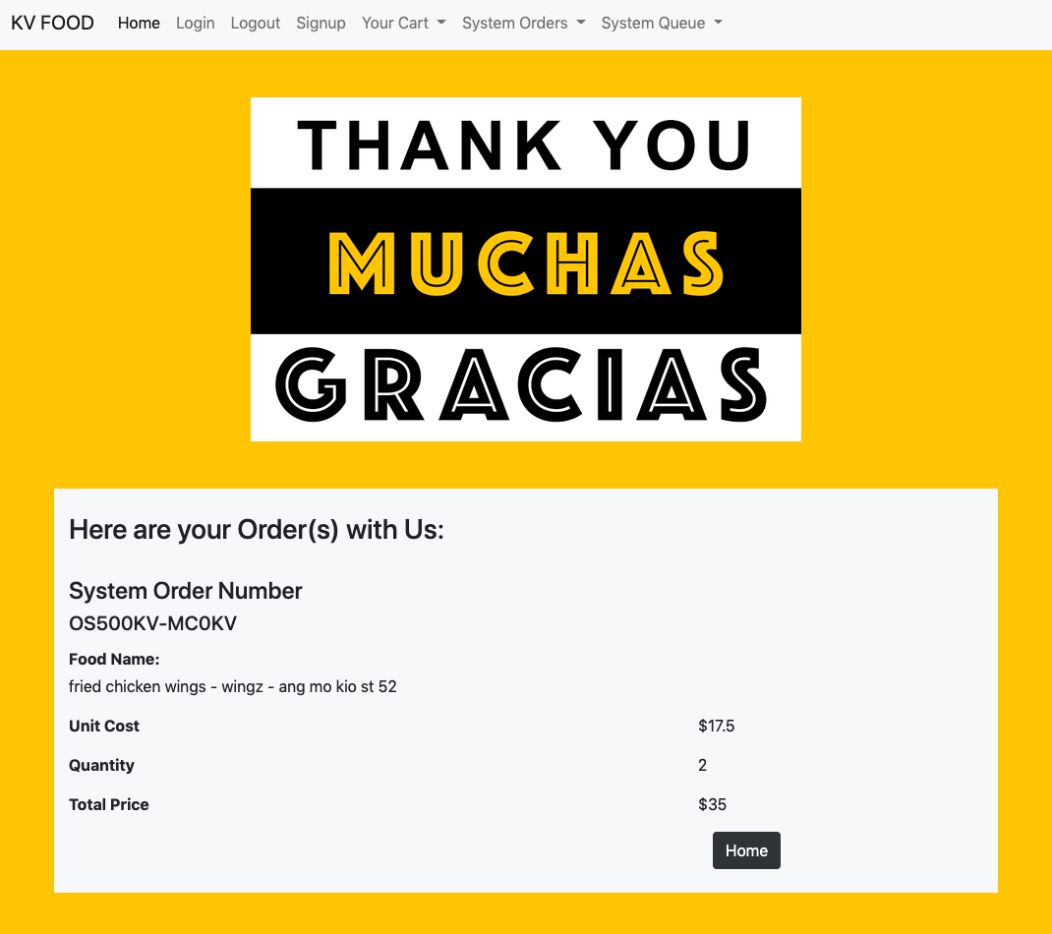

1. **Rinse and Repeat to add more items into your cart.**

You can search for other food items in the search bar.

Popular search items include *ice cream, mala xiang guo and hokkien mee*

We will **checkout** ice cream, and enter a priority value of : **55**

We will **checkout** mala, and enter a priority value of : **25**

We will **checkout** hokkien mee, and enter a priority value of : **100**

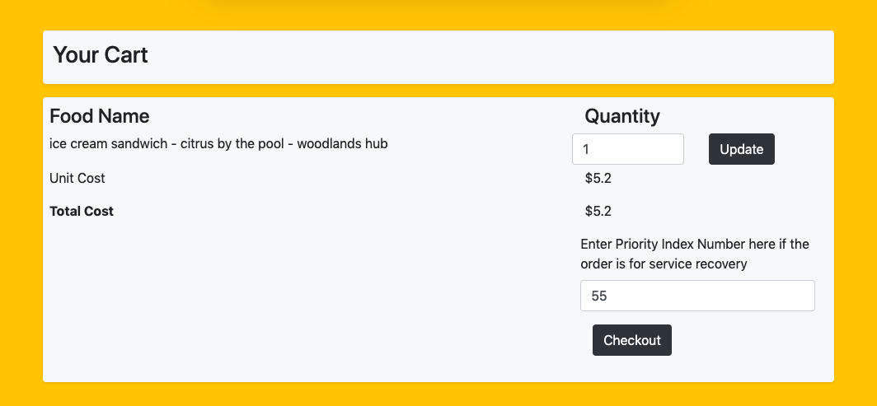

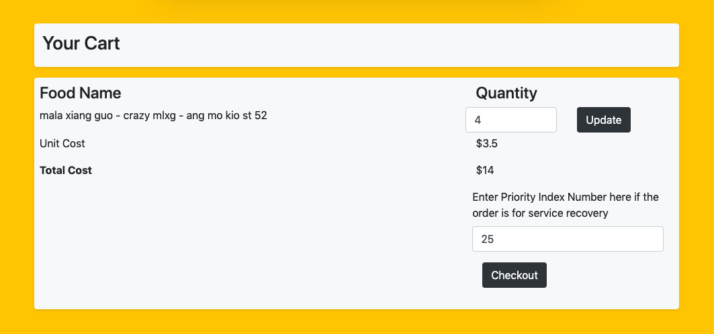

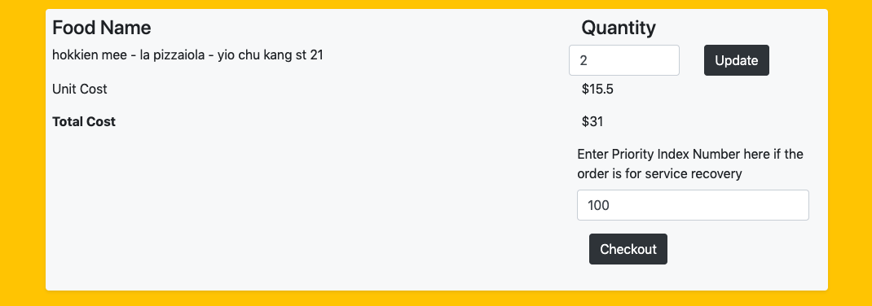

1. **Check All Transactions if you're a #superuser!**

The transactions on this page are sorted in chronological order (latest first, in descending order) to ensure we can always have a good gauge on when the last order was made.

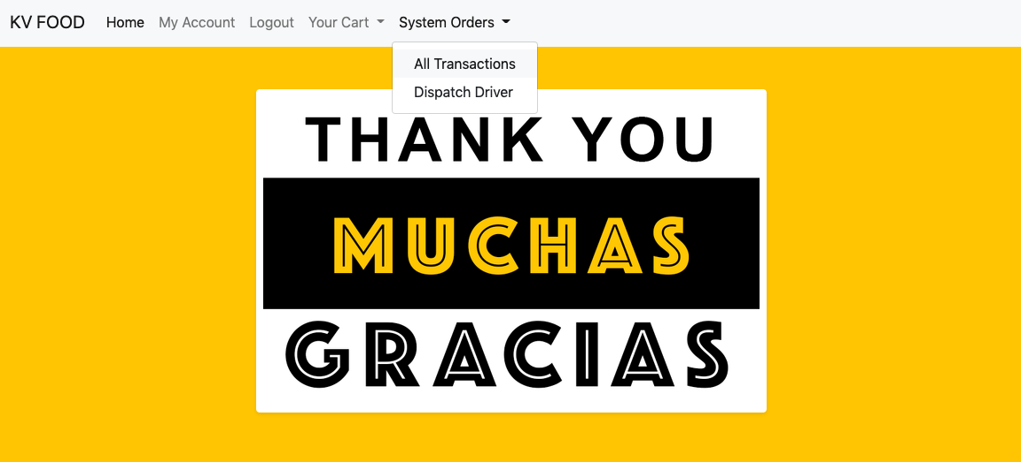

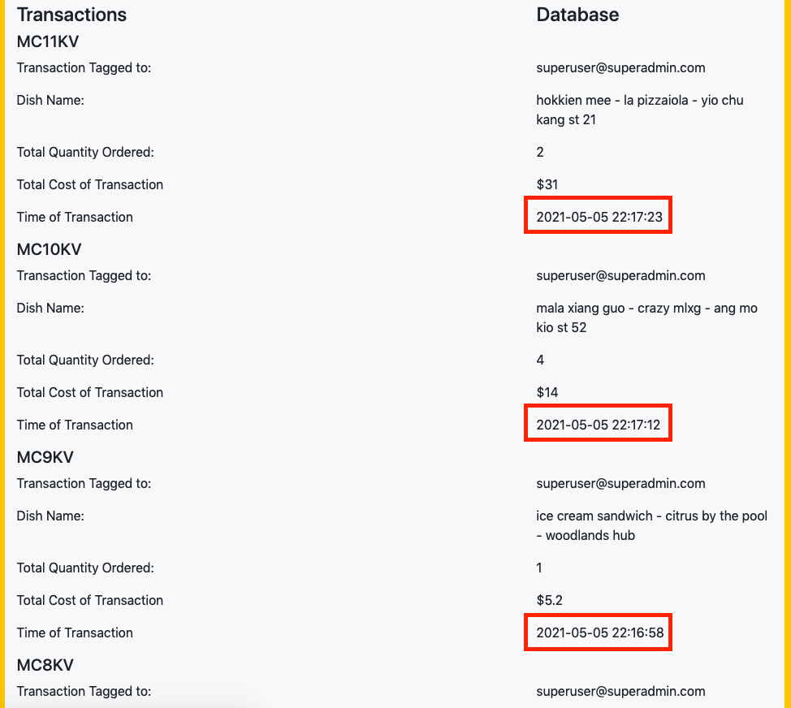

1. **Priority Index Value Is working!**

You can check out how priority values are working through the dispatch menu. The higher the priority index of an order, the sooner it should be dispatched first!

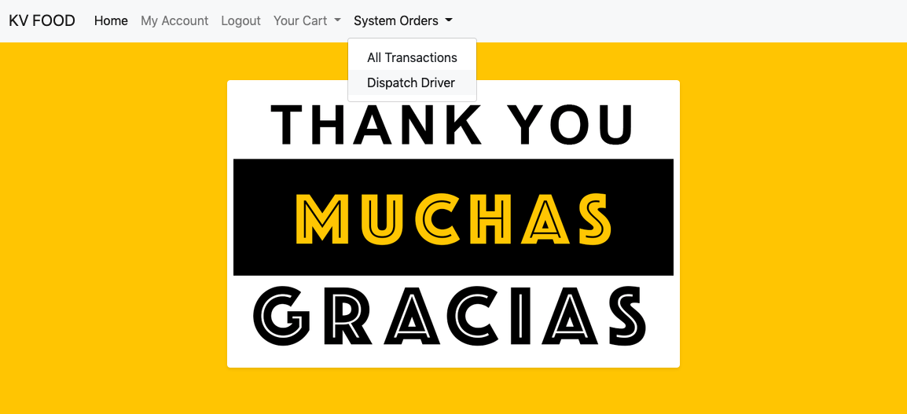

Even though we checked out hokkien mee last, do you remember that we gave it a priority value of 100? And since 100 is more than 99, the hokkien mee order number in the system, OS522KV is above OS516KV!

And since OS518KV has a priority value of 55 and since 55 less than 99, OS518KV is right below OS516KV. Similarly, OS520KV that has a priority value of 25 and since 25 is less than 55, it's right below OS520KV

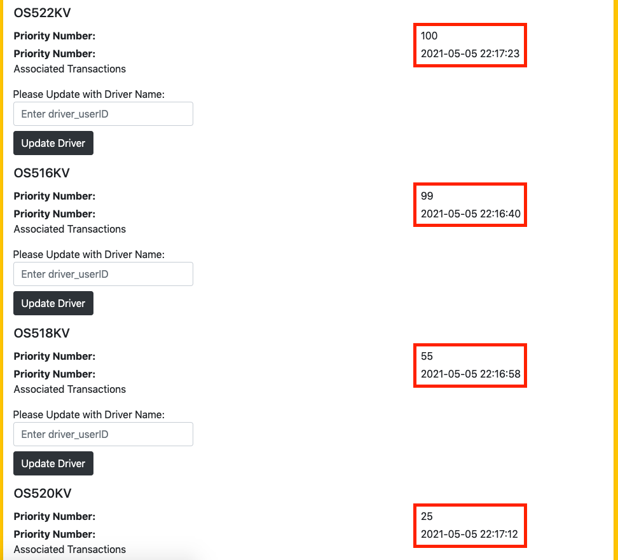

1. **Manual Driver Assignment**

While automatic driver assignment would be great; it's not integrated in the system just yet! So we'll have to manually do it. Head over to the same dispatch menu again.



1. **Every order needs a driver partner name**

You can give them any names you like. Remember to click the "Update Driver" button to ensure data gets saved in the system. All the orders should have a delivery driver name! So go ahead and update them all for orders that have the Update Driver Button present.

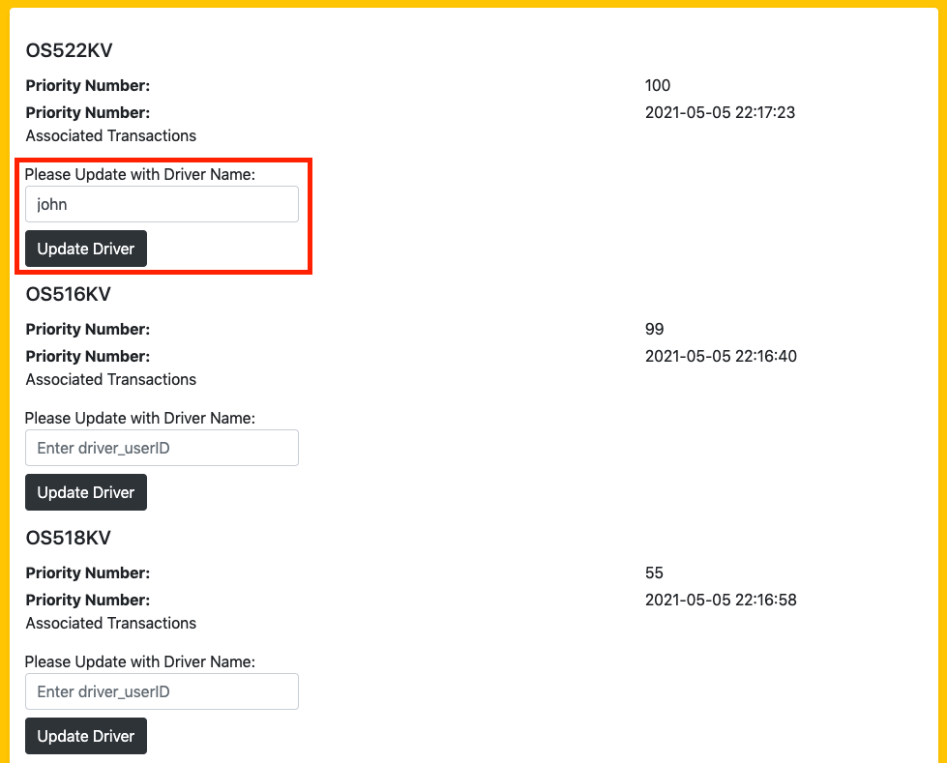

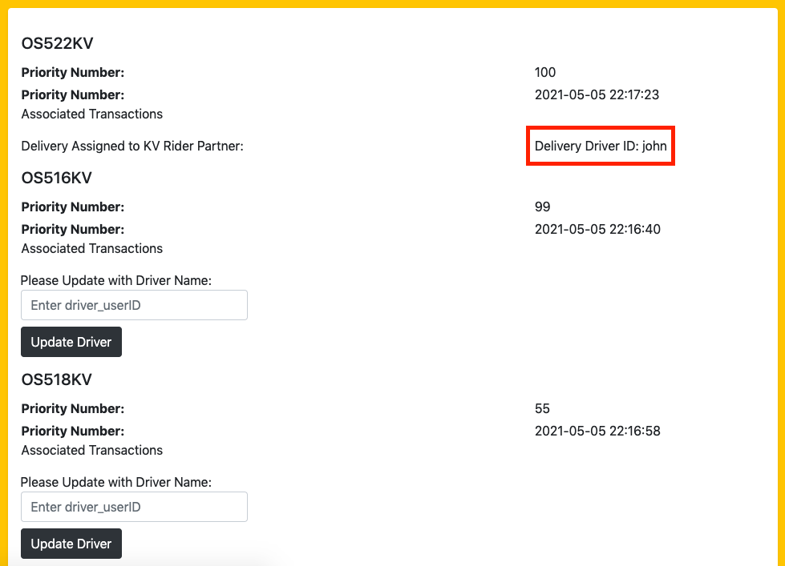

1. **User Profile Management**

Apart from making orders for your favorite food item, you can also manage your account settings through the dedicated user page found in the My Account main menu.



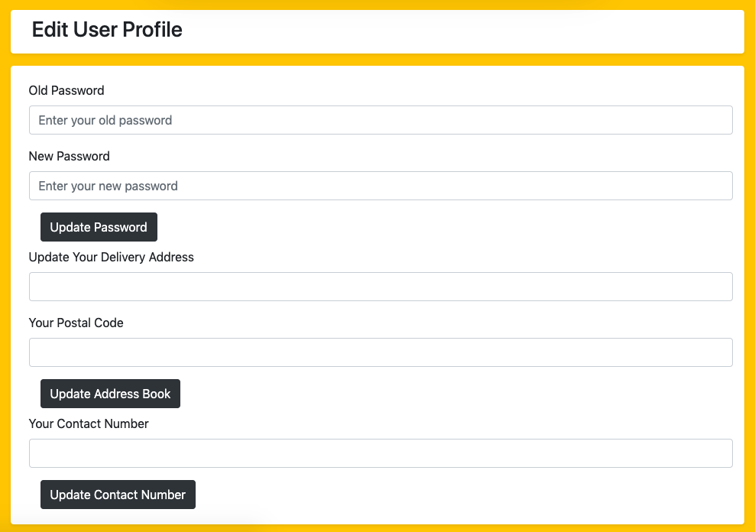

1. **Marketing prowess through Data**

With marketing being a key aspect of a business's growth, the KV food delivery's data system ensures that a user's search items, keywords and history are logged and can be sorted in chronological order.

This makes it a piece of cake for the marketing team to drive unique and tailored marketing campaigns!

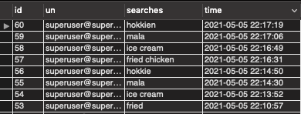

1. **Bonus.**

Sign up for an account that is of **user** type instead of superuser and try to do what you've done in this instructions guide.

If you get redirected and shown an empty plate; you know that you don't have access privileges. :)

Choose 'user' type to sign up for a normal account with no superuser#1 privileges

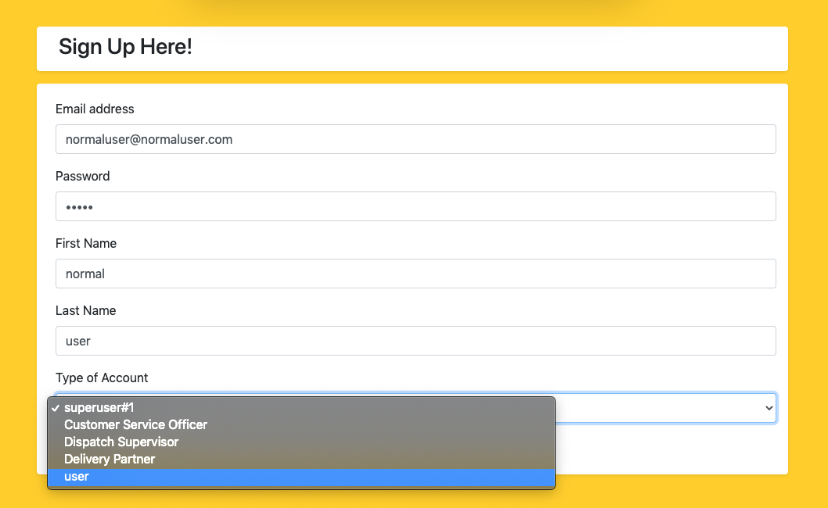

In your cart, you no longer can input priority values.

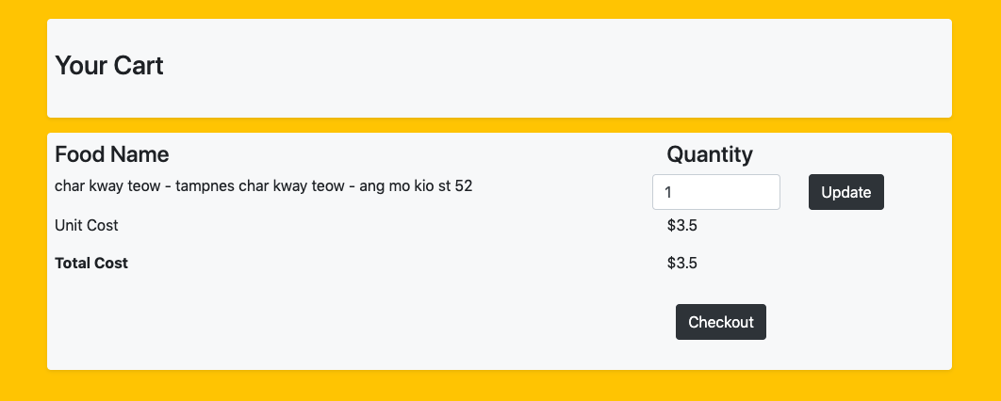

Trying to access top level system menu options are also no longer allowed. You'll be greeted with our 404 and redirected in seconds.

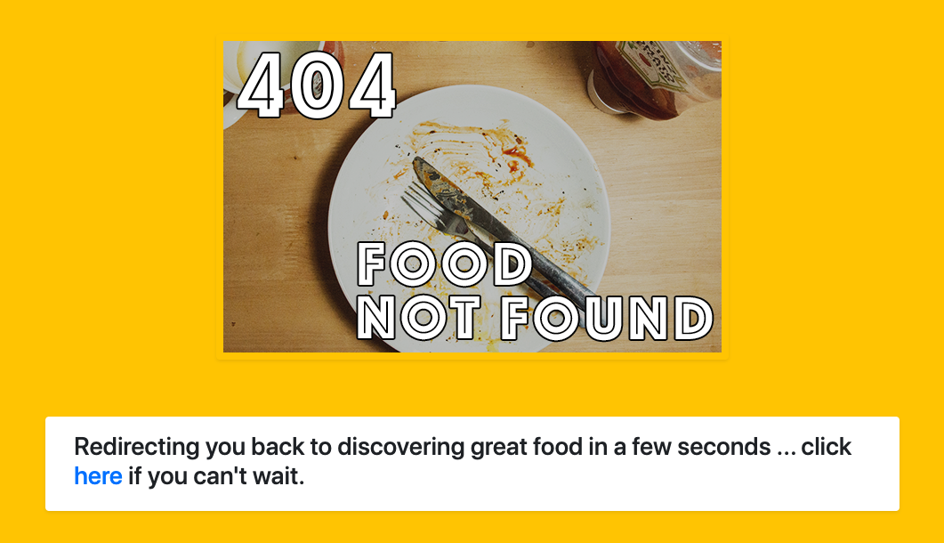

This marks the end of the instructions manual. We hope you've enjoyed trying and using the web app as much as I've learnt and spending the time building it.